 COSC 3380
Name: __Thanh Vo_________ Seat #D9

Project 1:
(100 points)
(Due date found in the COSC 3380 BB Calendar!)

1.a 0 points
1.b 30 points
1.c 10 points
1.d 10 points
2. 20 points
3. 30 points

PLEASE ENTER YOUR GRADE IN THIS BOX & ALSO on the CHECK SHEET:

1. (50 points)

(Please do not turn in these lines in yellow.)

(Please do not change the attribute names.)

(Please do not change file names.)

a. (0 points – separate document) Using the above COSC3380 Data Requirements create the ERD Model (must fit on one page)
(Conceptual Model – What - Analysis).

(Just place the ERD Diagram HERE)
A1: CustomerID

A3: CustomerAddress

A2: CustomerName

A4: CustomerCity

E1: Customer
A5: CustomerState

R4: DoesBusinessIn

A9: CustomerPassword

A6: CustomerPostalCode

A7: CustomerEmail

A1: TerritoryID

E5: Territory

A8: CustomerUserName

R1: Submit

A2: TerritoryName

R5: ServedBy
A1: OrderID

A1: SalespersonID

E6: SalesPerson
E2: Order
A2: OrderDate

A2: SalespersonName

A6: SalespersonPassword

A3: SalespersonPhone

A5: SalespersonUserName

A4: SalespersonEmail

R2: OrderLine

A1: OrderedQuantity

A1: ProductID

E3: Product

A2: SalePrice

A2: ProductName

R3: Group
A3: ProductFinish

A4: ProductStandardPrice

A5: Photo
E4: ProductLine

A2: ProductLineName

A1: ProductLineID

E7: PriceUpdate

A1: PriceUpdateID

A2: DateChanged

A3: OldPrice

A4: NewPrice

b. (30 points) COSC3380 Relational Model (must fit on one page)
(Internal Model – How - Design).
#Relations/Tables: _7__
E7: PriceUpdate

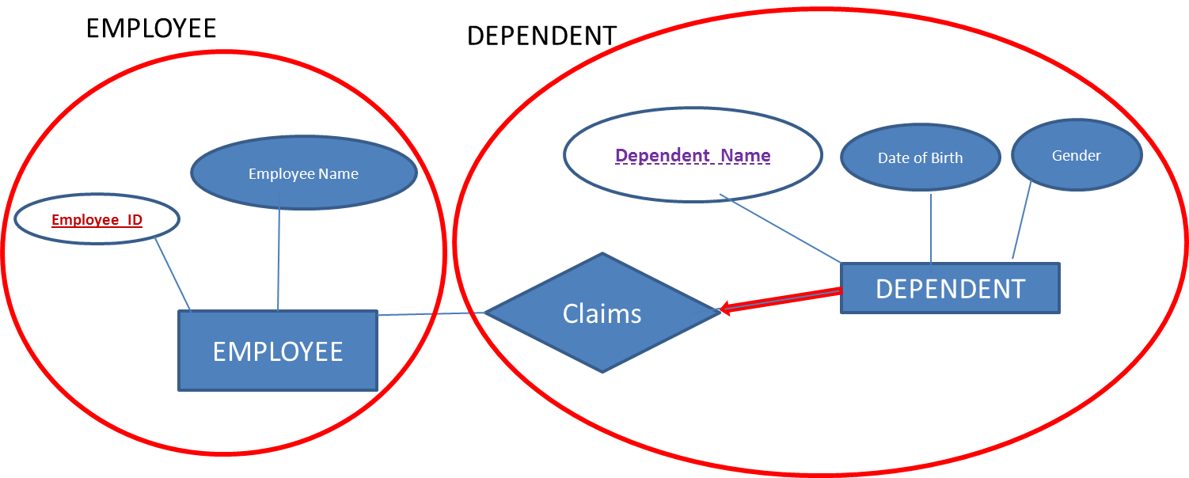
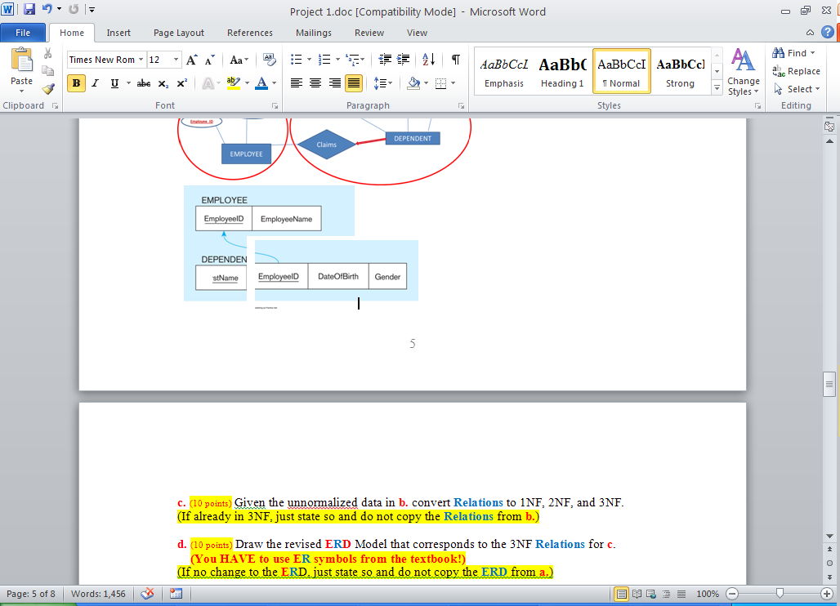

Customer

A1: CustomerID

A3: CustomerAddress

A2: CustomerName

DoesBusinessIn
A4: CustomerCity

E1: Customer
A5: CustomerState

R4: DoesBusinessIn

A9: CustomerPassword

Territory
A6: CustomerPostalCode

A1: TerritoryID

A7: CustomerEmail

E5: Territory
A2: TerritoryName

Order
A8: CustomerUserName

SalesPerson
R1: Submit

R5: ServedBy

A1: OrderID

A6: SalespersonPassword

A1: SalespersonID

E2: Order

E6: SalesPerson
A2: OrderDate

A5: SalespersonUserName

A2: SalespersonName

OrderLine
A4: SalespersonEmail

A3: SalespersonPhone

R2: OrderLine

A1: OrderedQuantity

A2: SalePrice

A1: ProductID

E3: Product

A2: ProductName

R3: Group
A3: ProductFinish

A4: ProductStandardPrice

A1: ProductLineID

A5: Photo

E4: ProductLine

Product
A2: ProductLineName

E7: PriceUpdate

A1: PriceUpdateID
ProductLine

A2: DateChanged
A3: OldPrice
A4: NewPrice
PriceUpdate

Customer

CustomerID | CustomerName | CustomerAddress | CustomerCity | CustomerState | CustomerPostalCode | CustomerEmail | CustomerUserName | CustomerPassword

Order
OrderID | OrderDate | CustomerID

OrderLine

OrderID | ProductID | OrderedQuantity | SalePrice

Product

ProductID | ProductName | ProductFinish | ProductStandardPrice | ProductLineID | Photo

ProductLine

ProductLineID | ProductLineName

DoesBusinessIn

CustomerID | TerritoryID

Territory

TerritoryID | TerritoryName

SalePerson

SalespersonID | SalespersonName | SalespersonPhone | SalespersonEmail | SalespersonUserName | SalespersonPassword | TerritoryID

PriceUpdate
PriceUpdateID | DateChanged | OldPrice | NewPrice

c. (10 points) Given the unnormalized data in b. convert Relations to 1NF, 2NF, and 3NF.
(If already in 3NF, just state so and do not copy the Relations from b.)

The relations are already in 1NF, 2NF and 3NF

d. (10 points) Draw the revised ERD Model that corresponds to the 3NF Relations for c.
(You HAVE to use ER symbols from the textbook!)
(If no change to the ERD, just state so and do not copy the ERD from a.)

There is no change to the ERD

2. (20 points)
Using SQL*Plus (Oracle DBMS) create the 3NF Tables from complete Project1 specified in 1. Display the structure for each Table after you created it. Make sure you implement all the necessary integrity constraints. SQL comment the SQL code. Turn in screenshots of each SQL command (SQL COMMENTS ARE A MUST) and its output as Project1.doc. SQL code needs to also be submitted to BB as Project1.sql.
9 RELATIONS:
/*Customer table*/
/*drop table with cascade constraint*/
DROP TABLE Customer CASCADE CONSTRAINTS PURGE;
/*create the table Customer*/
CREATE TABLE Customer (
CustomerID INTEGER CONSTRAINT Customer_cusid_pk PRIMARY KEY,
CustomerName CHAR(40),
CustomerAddress CHAR(60),
CustomerCity CHAR(20),
CustomerState CHAR(2),
CustomerPostalCode CHAR(10),
CustomerEmail CHAR(40),
CustomerUserName CHAR(15),
CustomerPassword CHAR(15));
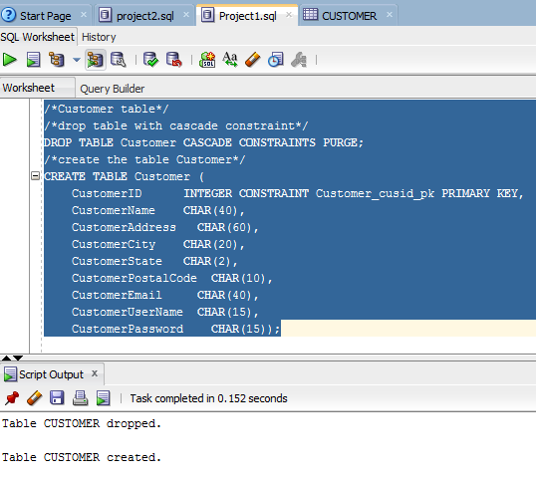

/*Order table*/
/*drop table with cascade constraint*/
DROP TABLE Orderr CASCADE CONSTRAINTS PURGE;
/*create the table Order*/
CREATE TABLE Orderr (
OrderID INTEGER CONSTRAINT Orderr_oid_pk PRIMARY KEY,
OrderDate DATE,
CustomerID INTEGER NOT NULL,
FOREIGN KEY (CustomerID) REFERENCES customer(CustomerID));
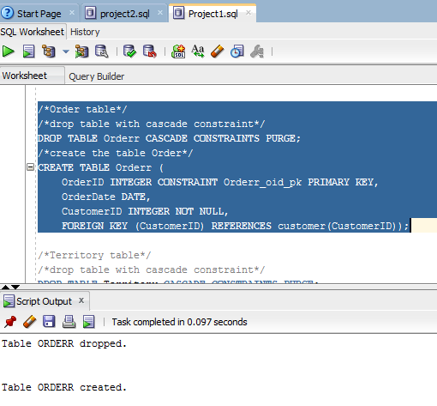

/*Territory table*/
/*drop table with cascade constraint*/
DROP TABLE Territory CASCADE CONSTRAINTS PURGE;
/*create the table Territory*/
CREATE TABLE Territory (
TerritoryID INTEGER CONSTRAINT SaleTerritory_terid_pk PRIMARY KEY,
TerritoryName CHAR(30));
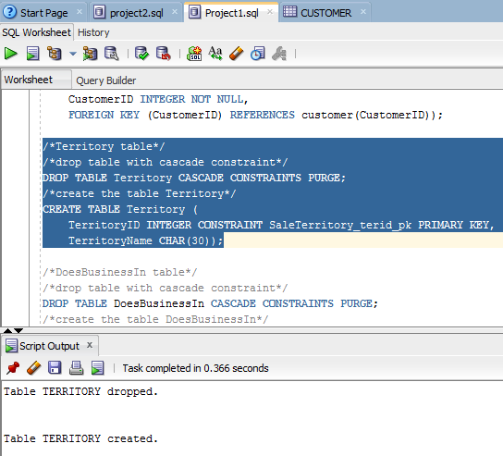

/*DoesBusinessIn table*/
/*drop table with cascade constraint*/
DROP TABLE DoesBusinessIn CASCADE CONSTRAINTS PURGE;
/*create the table DoesBusinessIn*/
CREATE TABLE DoesBusinessIn (
CustomerID INTEGER NOT NULL,
TerritoryID INTEGER NOT NULL,
PRIMARY KEY(CustomerID, TerritoryID),
FOREIGN KEY (CustomerID) REFERENCES Customer(CustomerID),
FOREIGN KEY (TerritoryID) REFERENCES Territory(TerritoryID));
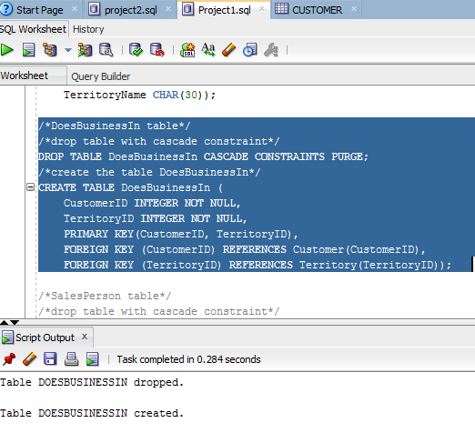

/*SalesPerson table*/
/*drop table with cascade constraint*/
DROP TABLE SalesPerson CASCADE CONSTRAINTS PURGE;
/*create the table SalesPerson*/
CREATE TABLE SalesPerson (
SalespersonID INTEGER CONSTRAINT Saleperson_perid_pk PRIMARY KEY,
SalespersonName CHAR(30),
SalespersonPhone CHAR(10),
SalespersonEmail CHAR(40),
SalespersonUserName CHAR(15),
SalespersonPassword CHAR(15),
TerritoryID INTEGER NOT NULL,
FOREIGN KEY (TerritoryID) REFERENCES Territory(TerritoryID));
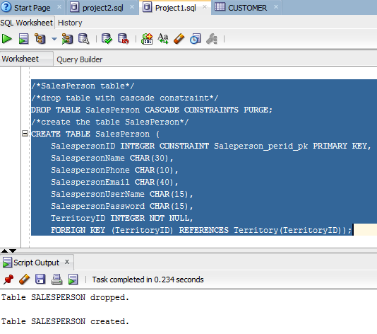

/*ProductLine table*/
/*drop table with cascade constraint*/
DROP TABLE ProductLine CASCADE CONSTRAINTS PURGE;
--/*create the table ProductLine*/
CREATE TABLE ProductLine (
ProductLineID INTEGER CONSTRAINT ProductLine_plid_pk PRIMARY KEY ,
ProductLineName CHAR(20));
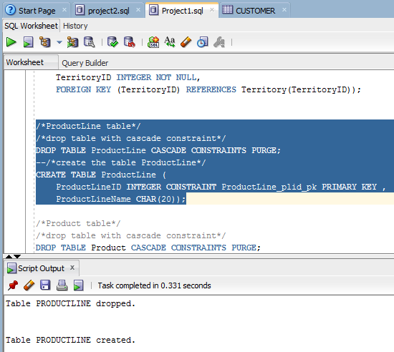

/*Product table*/
/*drop table with cascade constraint*/
DROP TABLE Product CASCADE CONSTRAINTS PURGE;
/*create the table Product*/
CREATE TABLE Product (
ProductID INTEGER CONSTRAINT Product_prodid_pk PRIMARY KEY,
ProductName CHAR(20),
ProductFinish CHAR(20),
ProductStandardPrice INTEGER,
ProductLineID INTEGER NOT NULL,
Photo CHAR(10),
FOREIGN KEY (ProductLineID) REFERENCES productline(ProductLineID));
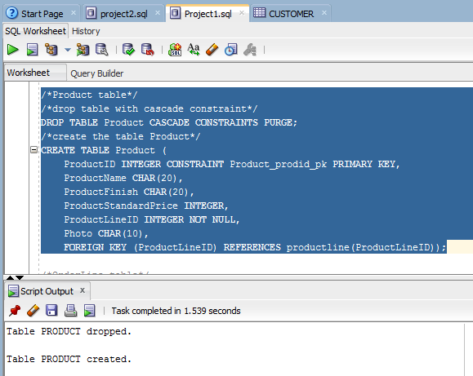

/*OrderLine table*/
/*drop table with cascade constraint*/
DROP TABLE OrderLine CASCADE CONSTRAINTS PURGE;
/*create the table OrderLine*/
CREATE TABLE OrderLine (
OrderID INTEGER NOT NULL,
ProductID INTEGER NOT NULL,
OrderedQuantity INTEGER,
SalePrice INTEGER,
PRIMARY KEY(OrderID, ProductID),
FOREIGN KEY(OrderID) REFERENCES Orderr(OrderID),
FOREIGN KEY(ProductID) REFERENCES Product(ProductID));
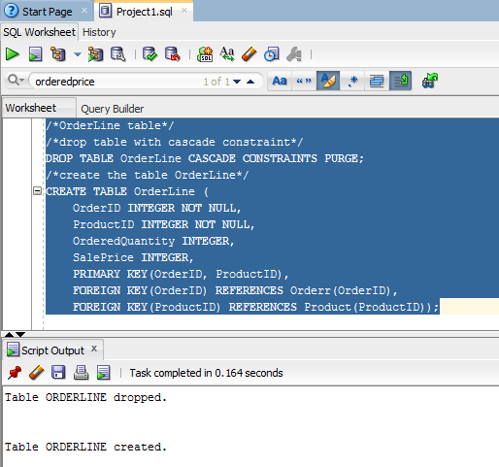

/*drop then create price update table*/
DROP TABLE PriceUpdate;
CREATE TABLE PriceUpdate (
PriceUpdateID INTEGER CONSTRAINT PriceUpdate_puid_pk PRIMARY KEY,
DateChanged DATE,
OldPrice INTEGER,
NewPrice INTEGER
);
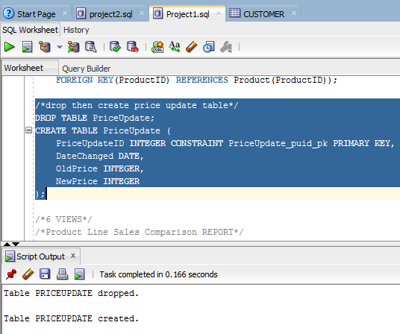

6 VIEWS
/*Product Line Sales Comparison REPORT*/
/*drop view for Product Line Sales Comparison REPORT*/
DROP VIEW Product_Line_Sales_Comparison;
/*create view for Product Line Sales Comparison REPORT*/
CREATE VIEW Product_Line_Sales_Comparison AS
SELECT PL.ProductLineID, PR.ProductID, PR.ProductName, SUM(OL.OrderedQuantity) AS sumquantity
FROM Product PR
JOIN ProductLine PL ON (PR.ProductLineID = PL.ProductLineID)
JOIN OrderLine OL ON (PR.ProductID = OL.ProductID)
GROUP BY PL.ProductLineID, PR.ProductID, PR.ProductName; 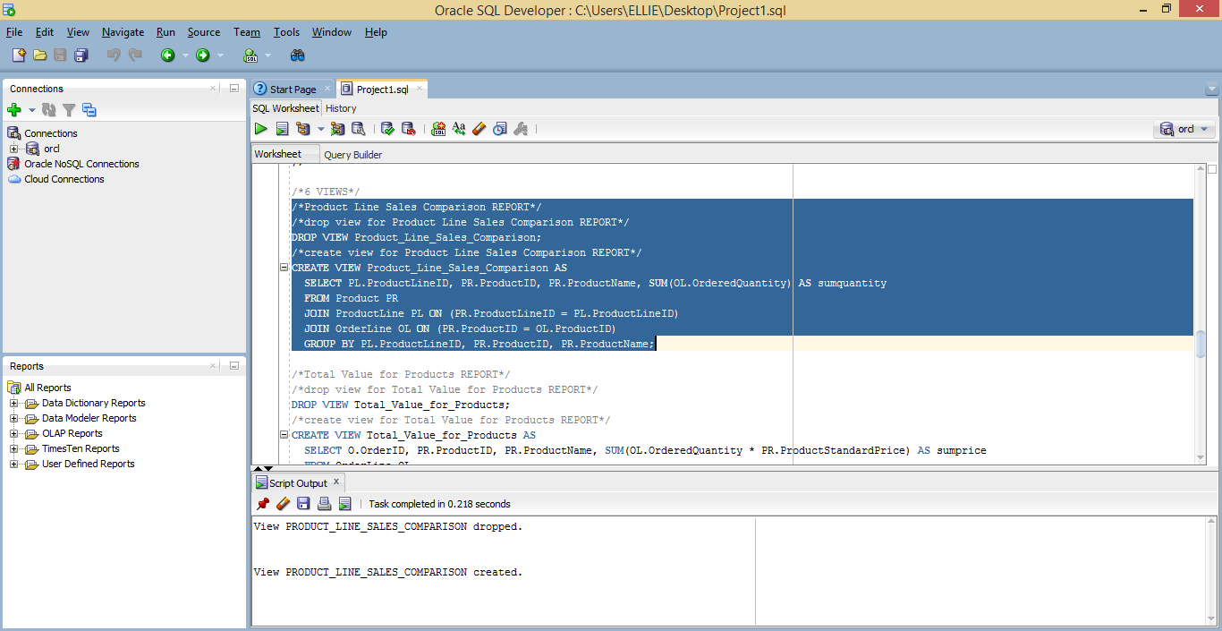

/*Total Value for Products REPORT*/
/*drop view for Total Value for Products REPORT*/
DROP VIEW Total_Value_for_Products;
/*create view for Total Value for Products REPORT*/
CREATE VIEW Total_Value_for_Products AS
SELECT O.OrderID, PR.ProductID, PR.ProductName, SUM(OL.SalePrice) AS sumprice
FROM OrderLine OL
JOIN Orderr O ON (OL.OrderID = O.OrderID)
JOIN Product PR ON (OL.ProductID = PR.ProductID)
GROUP BY O.OrderID, PR.ProductID, PR.ProductName; 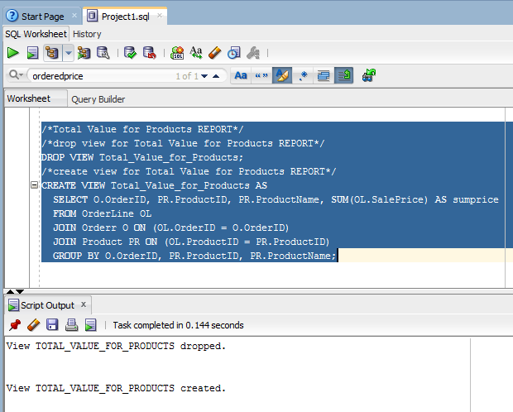

/*Data for Customer REPORT*/
/*drop view for Data for Customer REPORT*/
DROP VIEW Data_for_Customer;
/*create view for Data for Customer REPORT*/
CREATE VIEW Data_for_Customer AS
SELECT ST.TerritoryID, PR.ProductID, PR.ProductStandardPrice
FROM Territory ST, Customer CU, Orderr O, OrderLine OL, Product PR, DoesBusinessIn DB
WHERE ST.TerritoryID = DB.TerritoryID AND DB.CustomerID = CU.CustomerID
AND CU.CustomerID = O.CustomerID AND O.OrderID = OL.OrderID AND OL.ProductID = PR.ProductID; 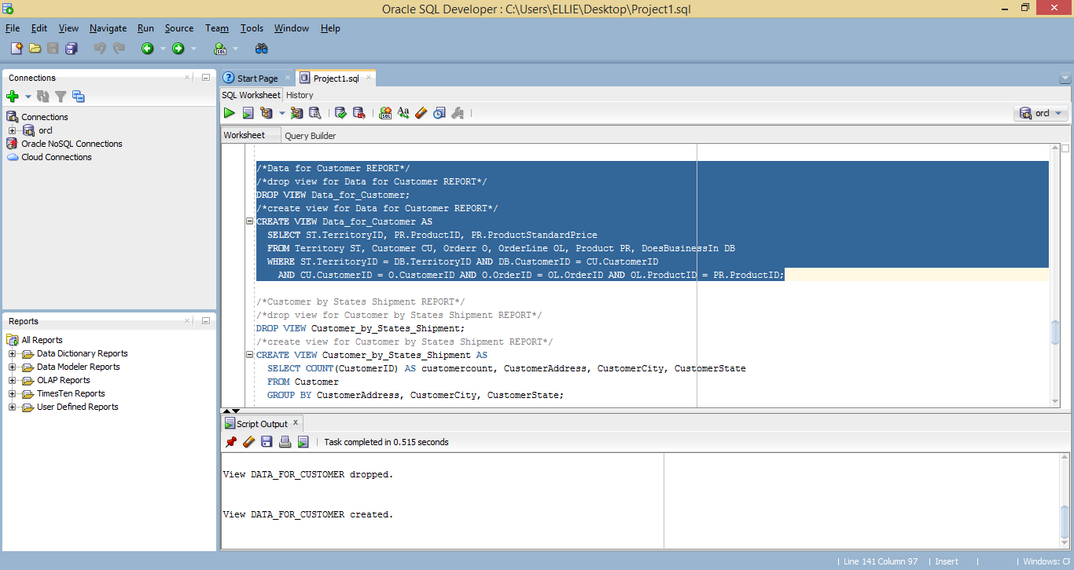

/*Customer by States Shipment REPORT*/
/*drop view for Customer by States Shipment REPORT*/
DROP VIEW Customer_by_States_Shipment;
/*create view for Customer by States Shipment REPORT*/
CREATE VIEW Customer_by_States_Shipment AS
SELECT COUNT(CustomerID) AS customercount, CustomerAddress, CustomerCity, CustomerState
FROM Customer
GROUP BY CustomerAddress, CustomerCity, CustomerState; 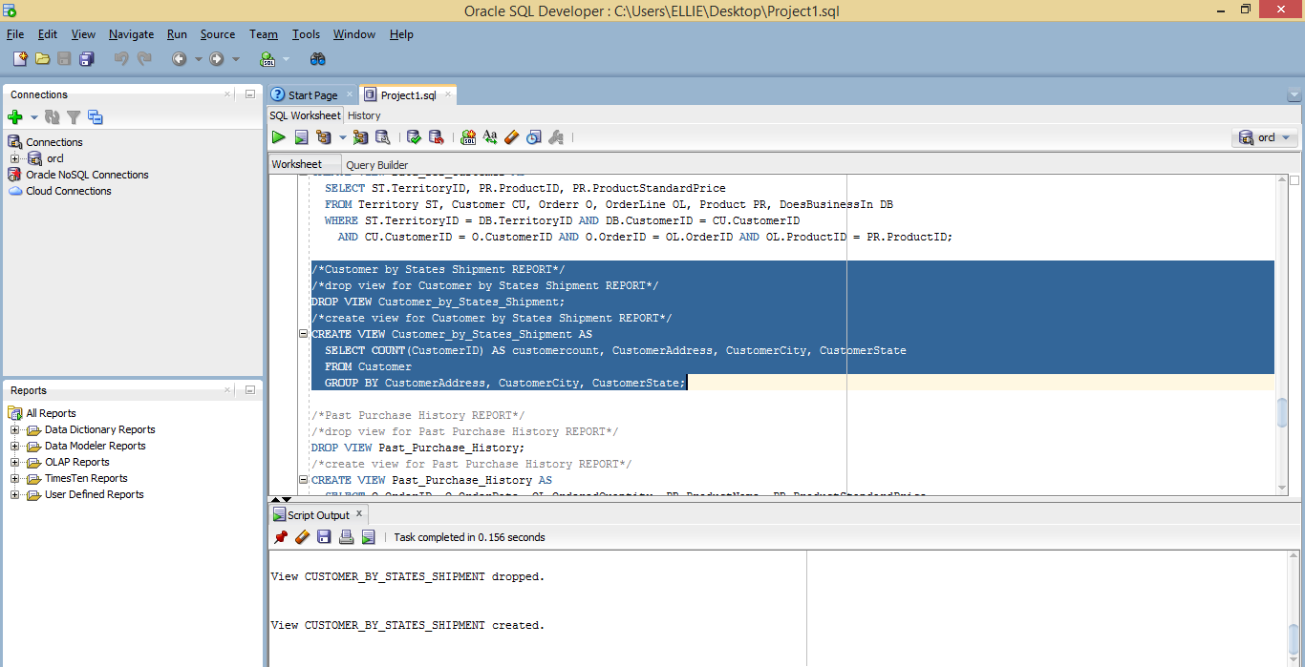

/*Past Purchase History REPORT*/
/*drop view for Past Purchase History REPORT*/
DROP VIEW Past_Purchase_History;
/*create view for Past Purchase History REPORT*/
CREATE VIEW Past_Purchase_History AS
SELECT O.OrderID, O.OrderDate, OL.OrderedQuantity, PR.ProductName, PR.ProductStandardPrice
FROM OrderLine OL
JOIN Orderr O ON (OL.OrderID = O.OrderID)
JOIN Product PR ON (OL.ProductID = PR.ProductID); 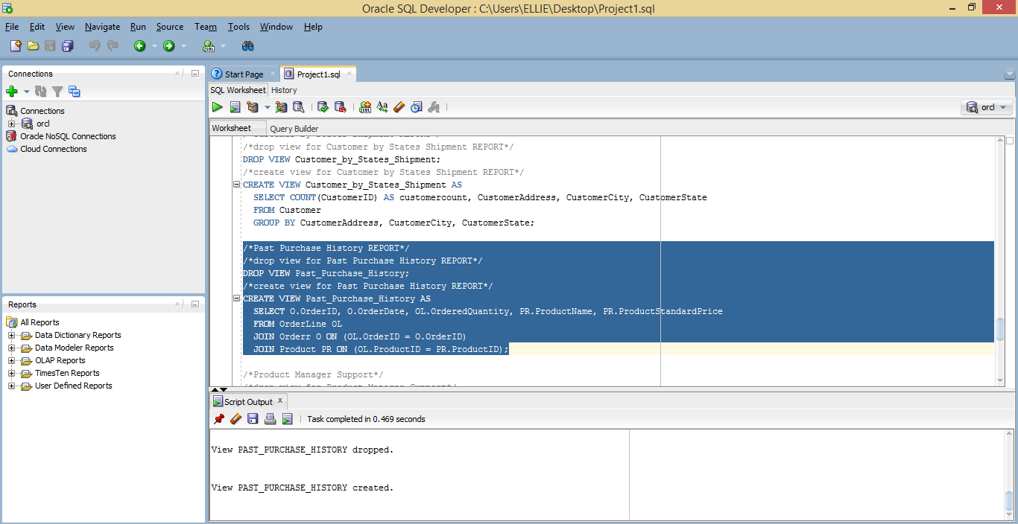

/*Product Manager Support*/
/*drop view for Product Manager Support*/
DROP VIEW Product_Manager_Support;
/*create view for Product Manager Support*/
CREATE VIEW Product_Manager_Support AS
SELECT Cu.CustomerID, Cu.CustomerName, Cu.CustomerPostalCode, Pr.ProductID, Pr.ProductName, Pr.ProductFinish, Pr.ProductStandardPrice,
Pr.ProductLineID, Pl.ProductLineName, O.OrderID, O.OrderDate, O.CustomerID orderredCustomerid, Ol.OrderID orderlineOrderid,
Ol.ProductID orderlineProdid, Ol.OrderedQuantity
FROM Customer Cu, Product Pr, ProductLine Pl, Orderr O, OrderLine Ol
WHERE (Cu.CustomerID = O.CustomerID) AND (O.OrderID = Ol.OrderID) AND (Ol.ProductID = Pr.ProductID) AND (Pr.ProductLineID = Pl.ProductLineID);
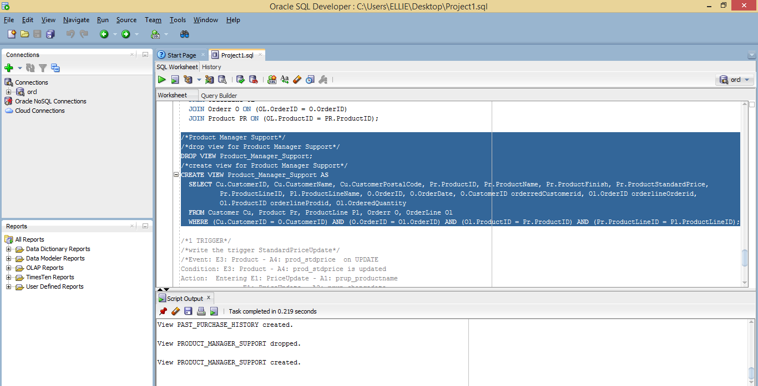

1 TRIGGER
/*write the trigger StandardPriceUpdate*/
/*Event: E3: Product – A4: prod_stdprice on UPDATE
Condition: E3: Product – A4: prod_stdprice is updated
Action: Entering E1: PriceUpdate – A1: prup_productname
E1: PriceUpdate – A2: prup_changedate
E1: PriceUpdate – A3: prup_oldprice
E1: PriceUpdate – A4: prup_newprice
*/
CREATE OR REPLACE TRIGGER StandardPriceUpdate AFTER UPDATE ON Product
FOR EACH ROW
BEGIN
INSERT INTO PriceUpdate(PriceUpdateID,DateChanged,OldPrice,NewPrice)
VALUES (1, NULL, 0, 0);
END; 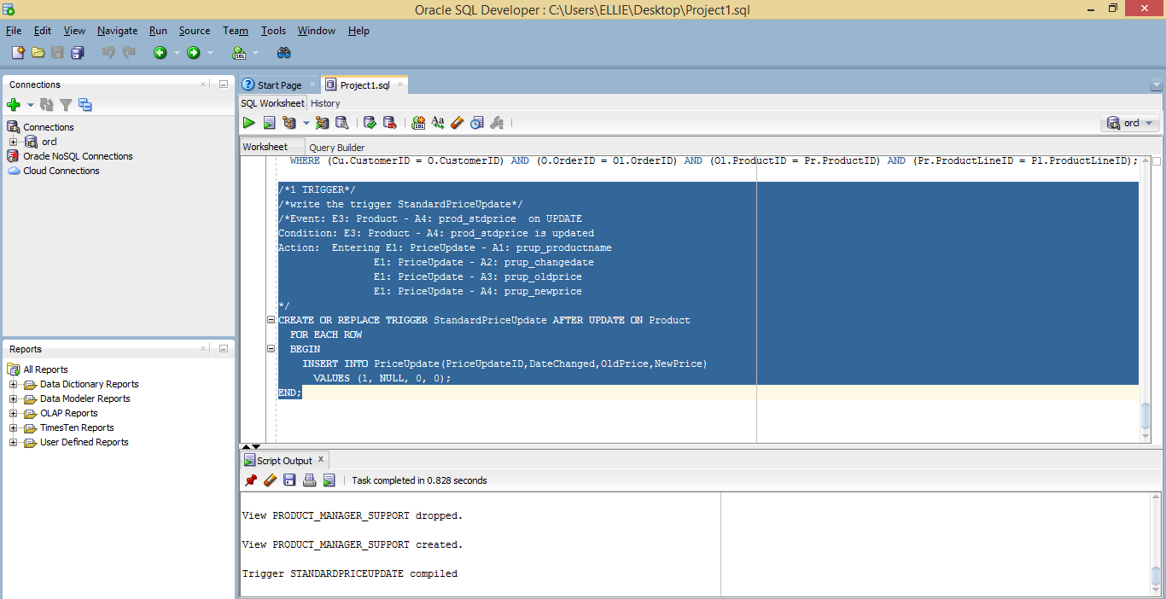

3. (30 points)
Create the COSC3380 Database tables in Microsoft Access DBMS (as Project1ACCESS) or Microsoft SQL Server 2008 DBMS (as Project1MSSQL) (available in the Computer Science LABS). Then request the Table Relationships Diagram for the Database. This will show you a visual representation of the COSC3380 Database. Turn in a screenshot of it. SQL code needs to also be submitted to BB as Project1ACCESS.sql or Project1MSSQL.sql.

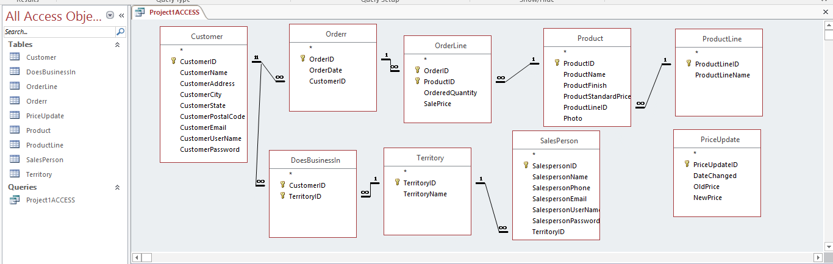

9 TABLES
